CIS179 Chapter 1 Lecture notes

Why study Networking: Statistics (Video: Why Study Networking Part 1: Statistics 3:05)
In 2019 there are about 4.3 billion users online about 56% of the world’s population (of 7.6 billion population)
3.5 billion are using social media
3.4 billion of them are using social media on their phones
50% of internet users are in the Asian continent
7% of Internet users are in North America
89.4% of the US population are on the Internet
80% of Americans have made an online purchase this month
96% of Americans have made purchases online in their lifetime.
40% of all purchases in America are made online
44% of purchases in America are at Amazon

Why study networkingPart II : Jobs (Video: Why study networking Part II: Jobs 4:32)
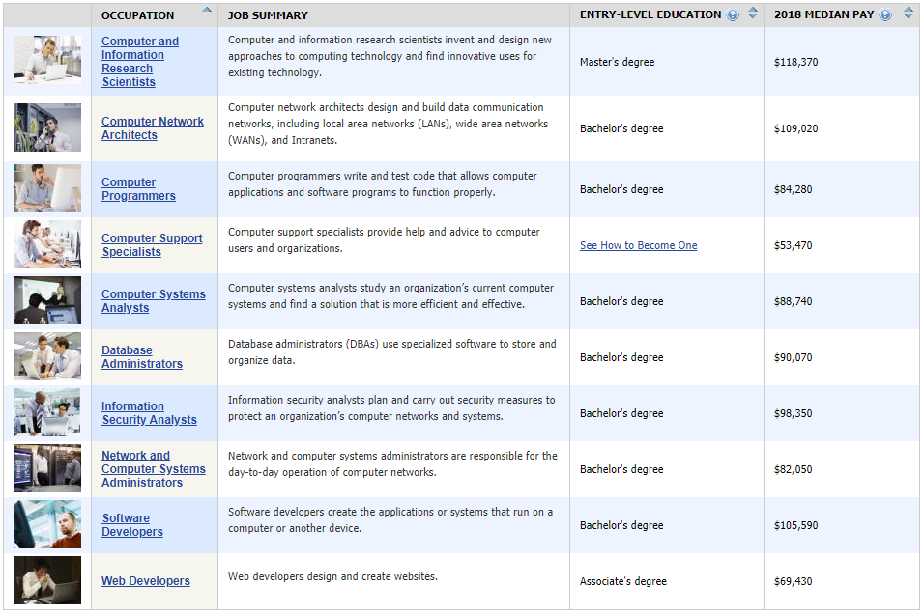

Terminology (Video: Terminology 4:44)
Data network: A transmission system that enables computer networking
Computer network: two or more computers or computer-enabled devices connected such that they can share data and resources.

Figure 1 Business network
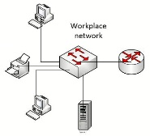
Figure 2 Home network
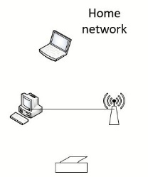
Other networks exist as well: POTS, Cell phone, electric grid, mail system, radio, broadcast TV
Convergence: When two technologies overlap
Examples: Cell system/Internet, TV/Internet, firewalls/content filters

Milestones (Video: Milestones in communication 6:39)
- Telegraph: Samuel Morse 1880, first remote distance communication
  - Demonstrates the three parts of communication, Information, Code, Signal
- Multiplexing: Combining multiple signals on one medium
  - Reduces cost (cabling is expensive)
- Switching: The ability to direct traffic to a desired destination
- Packetization: Ability to utilize more of the capability of the medium
  - Requires that messages be broken into segments at the sender end
  - Packetization reduces burstiness

Layering (Video: Layering 3:50)
Layering is breaking down the communication process into steps to accomplish several tasks
  - User information and commands (the input and output)
  - Segmentation and reassembly
  - Identifying source and destination
  - Check for errors and correct them
  - Signaling
These must account for both local and distance communication
- Switches handle local addressing
- Routers handle distance addressing
  - Hop: The transfer of data from one router to another is one hop

OSI Model (Video: OSI model Intro 3:14)
7. Application layer
6. Presentation Layer
5. Session layer
4. Transport layer
3. Network Layer
2. Data-Link Layer
1. Physical layer
- Standardization
- Interaction with only the next-door neighbor

TCI/IP Protocol suite (stack) (Video: Protocol suites 7:25)
- Protocol: A set of rules by which communication is performed
- Several are used during any one exchange of data – simultaneous use of multiple protocols.
- TCP/IP is a set of many protocols that are compatible with each other
- Each protocol communicates with those protocols at the neighboring layer

TCP/IP Model (Video TCP/IP model 4:08)
- Better fit with the TCI/IP protocol suite

- Application layer
- Transport layer
- Internetwork layer
- Network Access layer (sometimes called the Link layer)

The OSI model layers are referred to by number. Do not do that in the TCP/IP model.

P 23 Table 1.4 Network layer tasks (Video: Encapsulation and layer tasks 3:32)

Layer Number/Name | Task | Header/footer information
7, 6, 5 Application | User data/commands | User commands
4 Transport | Segmentation/reassembly | Sequence numbers, port numbers
3 Network | Distance addressing | IP address
2 Data link | Local addressing | Local address/Error check (footer)
1 Physical | Signaling | None

P24 Table 1.14 Protocols (Video: Common Protocols 3:12)
Layer | Protocols
7, 6, 5 Application | HTTP, SMTP, IMAP, DHCP, DNS, FTP
4 Transport | TCP, UDP
3 Network | IP
2 Data-Link | Ethernet, Frame Relay, ATM
1 Physical | AM, FM, Fiber, SONET, CDMA

Note the hourglass shape of the protocols. IP is central to all communication
P25 Table 1.15 Layer functions (Video: What the OSI layers do 4:33)
OSI layer | Layer function
7. Application | Data generation
6. Presentation | Coding. Preparation of data to the form in which it will be transmitted
5. Session | Create and terminate sessions
4. Transport | Segmentation, multiplexing
3. Network | IP addressing
2. Data-link | Error checking, local addressing
1. Physical | Convert from code to signals

Mnemonics
All people seem to need data processing
Programmers do not throw sausage pizza away
Table of Protocol Data Units (PDU) (Video: OSI PDUs 2:01)
OSI layer | Layer function
7. Application | Data
6. Presentation | Data
5. Session | Data
4. Transport | Segment
3. Network | Packet
2. Data-link | Frame
1. Physical | Bit

Table of equipment (Video: OSI Devices 1:14)
OSI Layer | Equipment
7, 6, 5 Application | End-user equipment (hosts)
4 Transport | End-user equipment (hosts)
3 Network | Routers (perform routing across networks)
2 Data-Link | Switches (local communication)
1 Physical | Wire, Radio signals, Fiberoptic, NIC, Hub, Repeater

